**Project Report**

Sneaker Store DB

Warren Kabuchi, Devotion Ekueku, Peter Henshaw

The goal of creating this database is to track a sneaker retail business.

The database we will use is MySQL Workbench

The database should be able to record the name of the sneaker, an identifying ID for the sneaker, color, date of receipt, date sold, price, and general description of the sneaker. `

The database will be able to track customers, name addresses, names, and phone numbers.

We intend to implement a cloud solution so that future growth does not impair the efficiency of using the database.

User requirements:

- create a users generic information table for all personales that will directly or indirectly read/write/modify the database (Example of types of user: Customers, Employees, delivery personal/3rd party services)

- Users must create an account with Name, Address, Email and Phone number.

- For online purchases users must be 16 and above.

- Users must cancel orders within 3 hours of order before the order is confirmed.

-Users need to put in a request for return items and most provide an address again for return

-Once received at the warehouse returns must be verified of good condition for refunds or exchange order

-User will receive tracking information/shipping updates after its been shipped out

-Users must always pick size and gender before ordering

-Table of rare items/shoes where users need to win a raffle to buy a single item

**Business Rules:**

1. **A SHIP DATE cannot be prior to an ORDER DATE for any given order**
2. **One order can only be for one customer**
3. **One shoe can have one or more brand**
4. **One shopping cart can only have one customer**
5. **One customer can only have one shopping cart.**

**Entity-Relationship Diagram (ERD) of the system:**

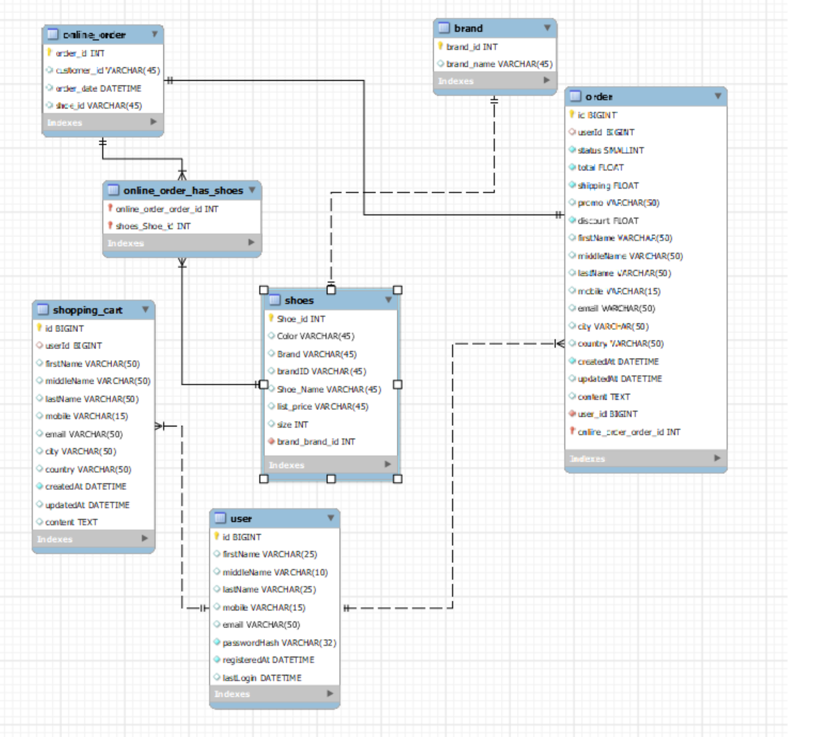

Data dictionary of the system:

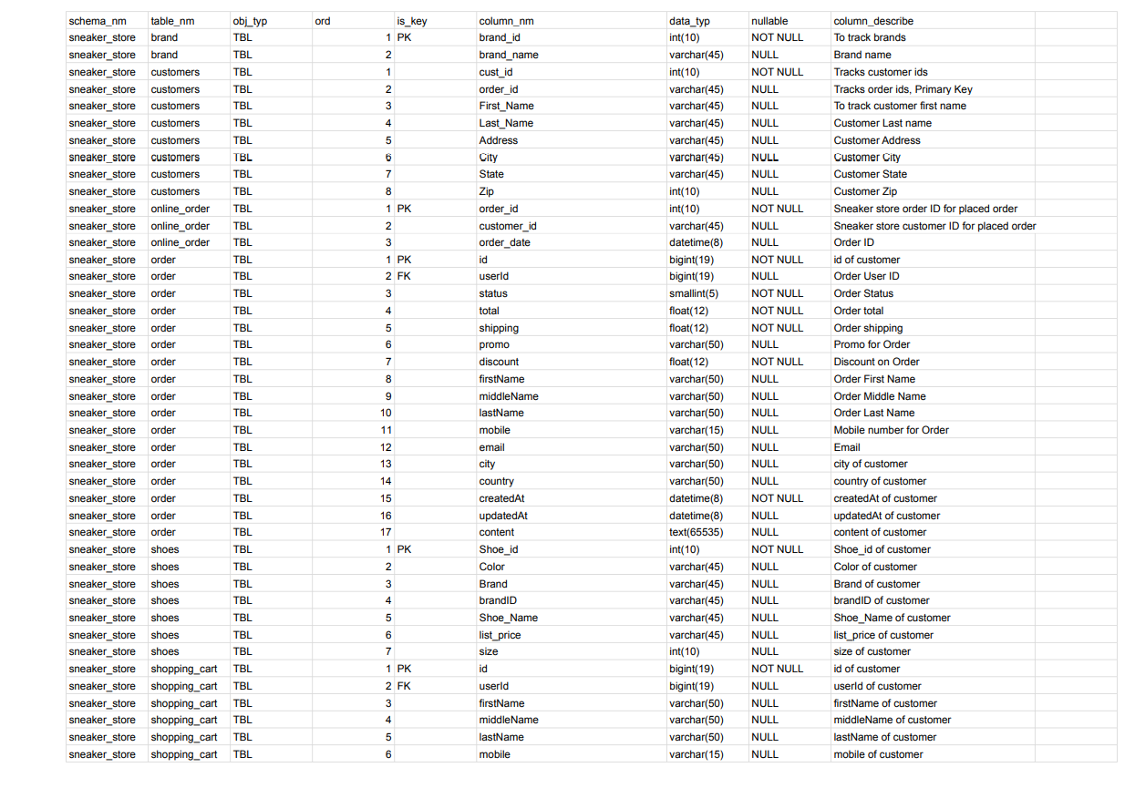

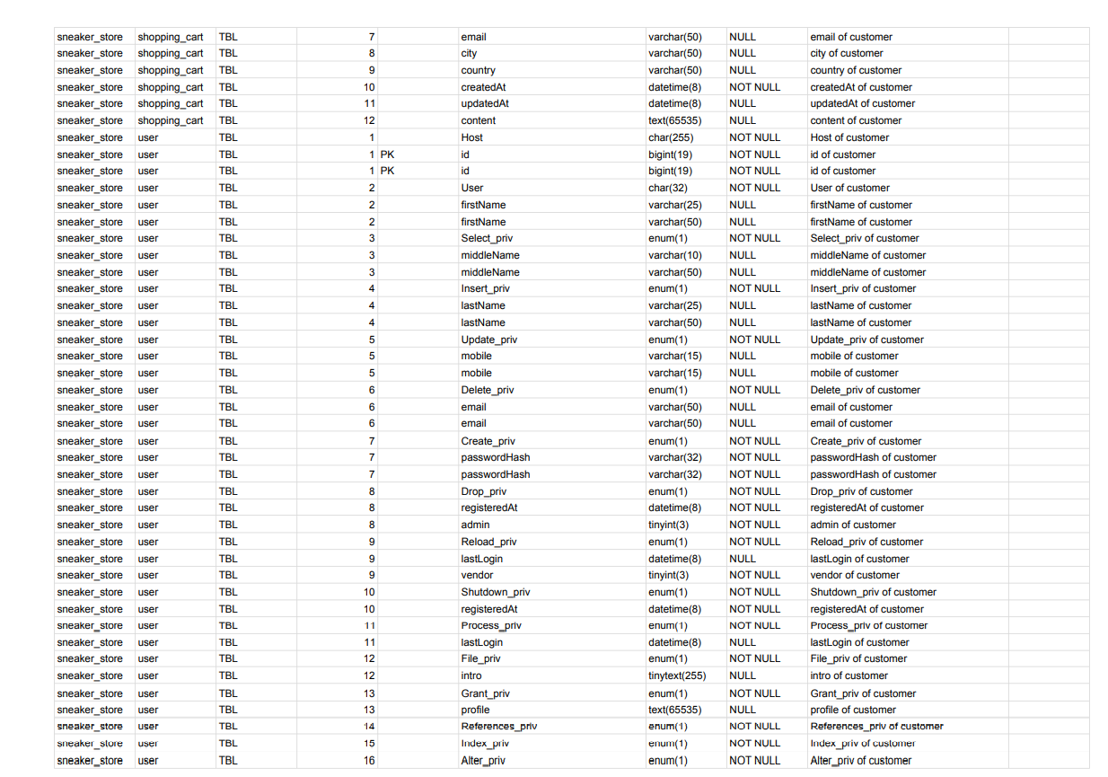

2.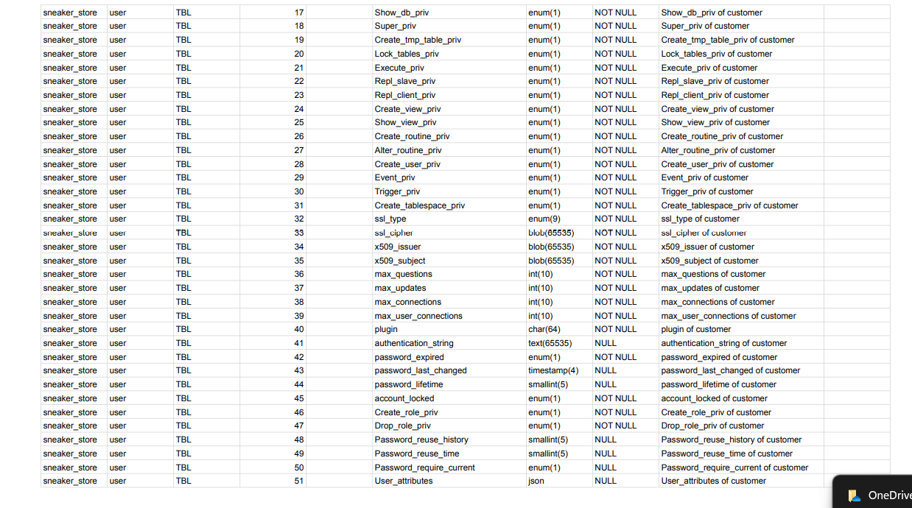

***Data Entry and Update :***

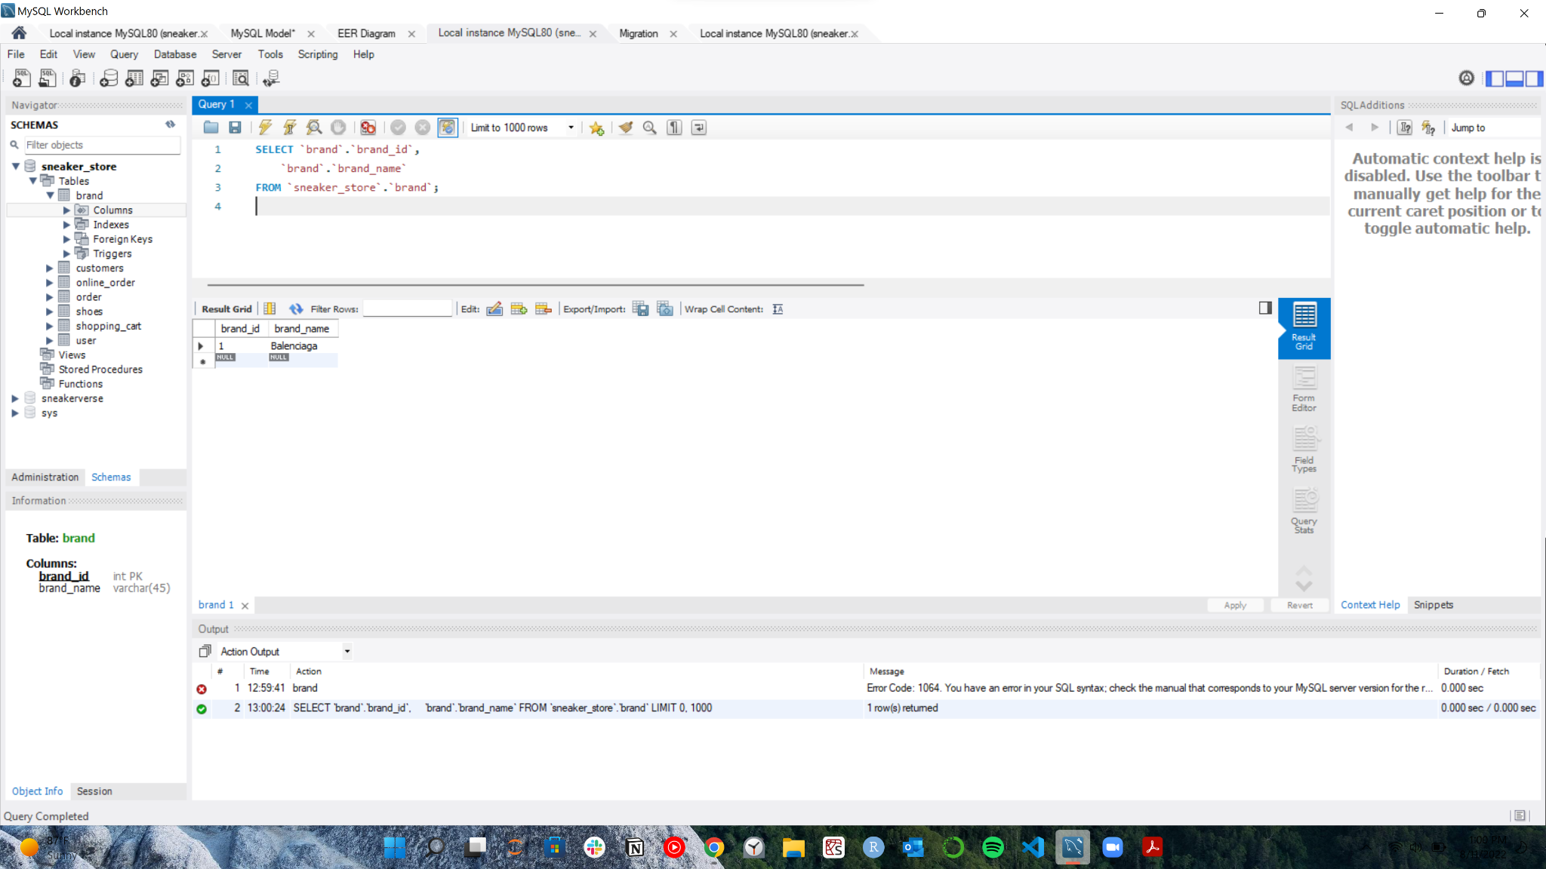

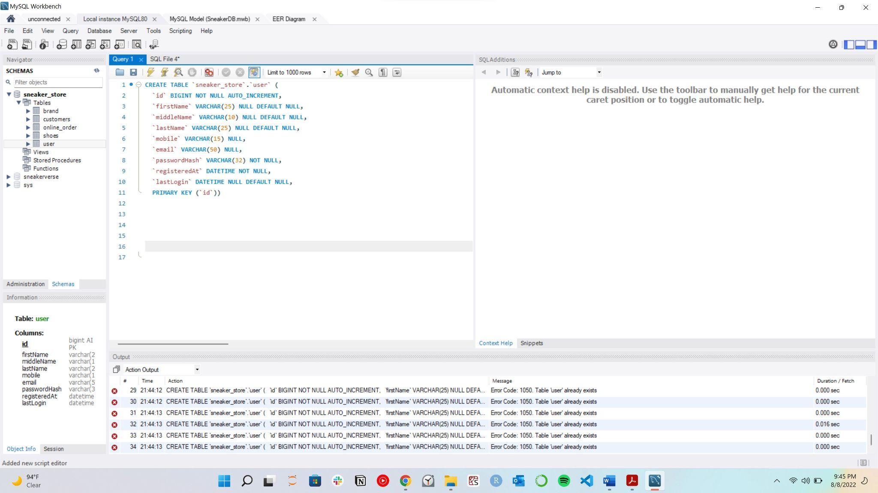

***Data Retrieval and Simple Reports:***

